**UNIVERSITY ADMIT ELIGIBILITY PREDICTOR**

**PRIOR KNOWLEDGE:**

**SUPERVISED AND UNSUPERVISED LEARNING:**

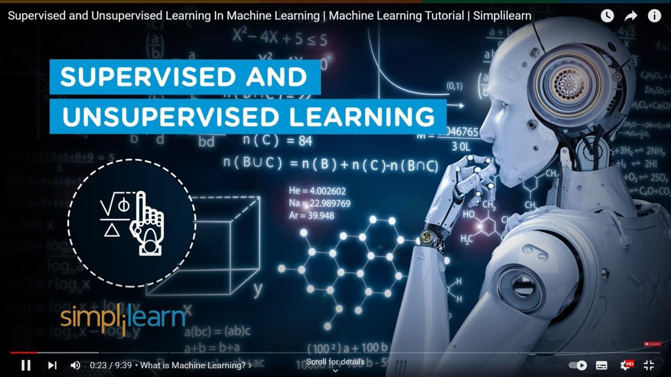

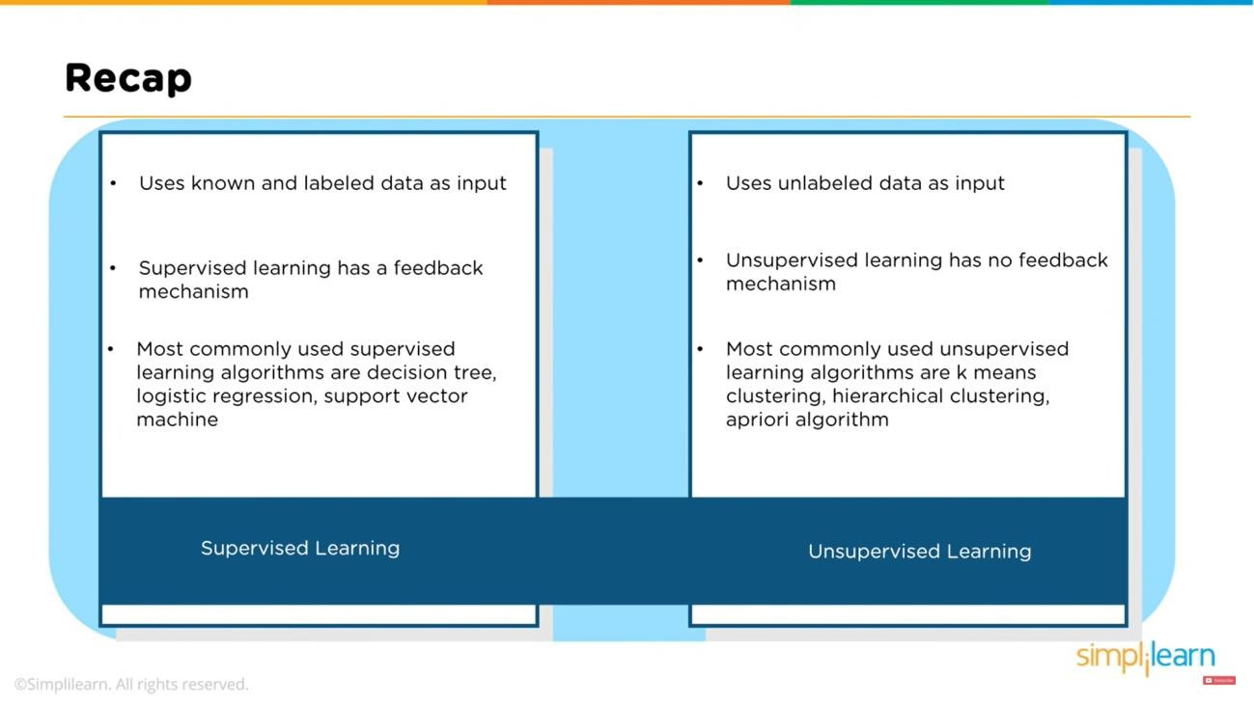

**REGRESSION CLASSIFICATION AND CLUSTERING:**

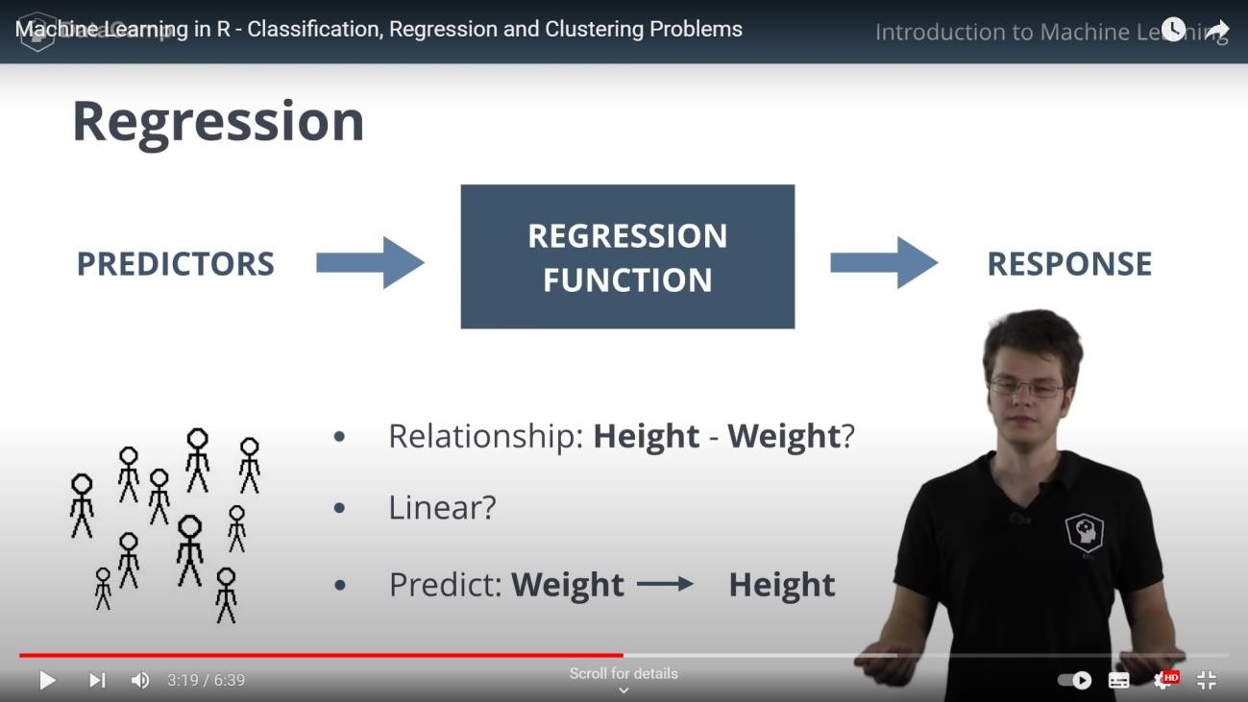

**FLASK:**

